**Intelligent video and audio recorder**

**user's manual**

version number ：V2.3

**basic operation**

**1. Turn on the machine**

**Hold down the power button of the law enforcement recorder for 3 seconds to turn on/off the recorder.**

**2. Video**

**Press the video button to start recording, press the video button again to stop recording.**

**3. Recording**

**Press the recording button to start recording, press the recording button again to stop recording.**

**4. Take pictures**

**4.1 Press the photo button to record the command immediately. When recording, press the photo button to capture photos.**

**5. Playback and data management**

**5.1 On the main interface of the recorder, press the return key at the lower right corner of the screen, and click file playback to view the recording, video and picture files of the recorder on the local machine.**

**5.2 The data can also be linked to the computer to view the recorder files and data management.**

**5.2.1 After the recorder is connected to the computer, open the IPCzmera folder**

5.2.2 Audio is audio file, Image is photo file, Viideo is video file, and the marked video file name will have IMP mark.

图形用户界面, 文本, 应用程序

**6. Intercom**

**6.1 First, make sure that the server and device binding are complete.**

**6.2 Press the PPT key for voice intercom, and release the button after the intercom is completed.**

**7. LED lights**

**Long press the recording button for 3 seconds to turn on/off the LED white light.**

**8. Red and blue flashing**

**The "M" key in the lower left corner of the long recorder opens/closes the red and blue flashing lights.**

**9. Laser lights**

**Long press the video button for 3 seconds to turn on/off the laser light, which can assist in positioning the camera.**

Note: Laser lamp function is not standard.

**10. File upload**

**First, ensure the device is online. On the recorder preview interface, press the back button to return to the function interface, then click on Settings-Platform Settings. Find the automatic upload switch; it is usually in a default off state. Once enabled, the recorder will start uploading while recording. To disable automatic upload, go to the playback interface and long-press the file you want to upload for one second in the file list, and an upload option will appear.**

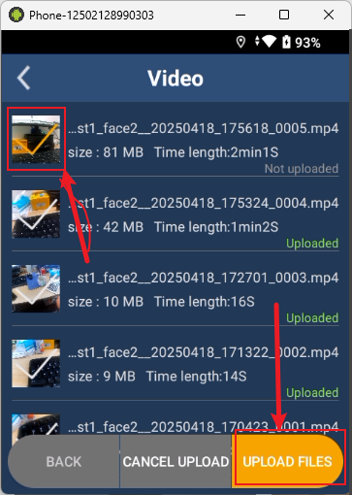

**Detailed introduction of the recorder**

**Main menu interface**

**The recorder will automatically open the preview interface. In the preview interface, press the return button in the lower right corner to enter the main function interface. There are several functional modules such as "cluster intercom", "law enforcement record", "message notification", "file playback", "application management" and "setting**

**"**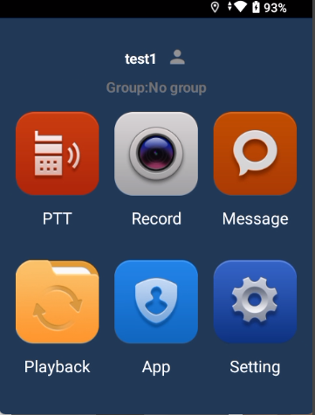

**1 Cluster talk**

**Cluster talk is a form of half-duplex group communication that allows you to speak by pressing and holding. One way is to long-press the "PTT button" on the right side to request speaking rights, and release it to relinquish them. The other way is to hold down the circular icon in the interface to request speaking rights, and release it to relinquish them.**

**User login: Click More for related Settings**

**Server: Enter the server IP address**

**Communication port: input data interaction port**

**Account: Enter the login account**

**Password: Enter the login password**

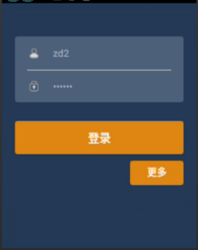 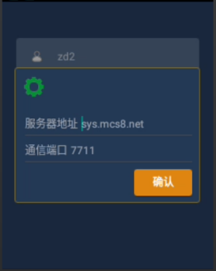

**After login, the interface is as follows:**

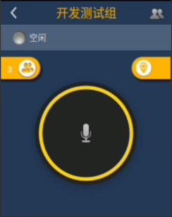

Click  You can check the status of the people in the intercom group to facilitate direct voice and video calls.

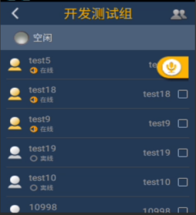

Click  Location list, users can enter the map to see all the location information of the group.

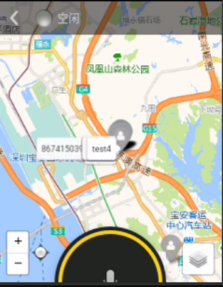

Press 未标题-2 You can apply for the right of speech, and release it when you let go。

ClickYou can enter the intercom group switch (assuming that cross-departmental scheduling is open in the background)

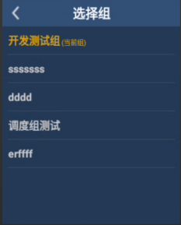

**address list**

You can view all members in the organization in the address book, basic information and status. You can also initiate voice calls and video calls for a member, and check the real-time location of the member。

Click  Initiate two-way voice calls

Click 未标题-2 Initiate two-way video calls

The video call interface is shown below：

**2 Law enforcement records**

Click卡通人物

中度可信度描述已自动生成Enter the law enforcement instrument view interface

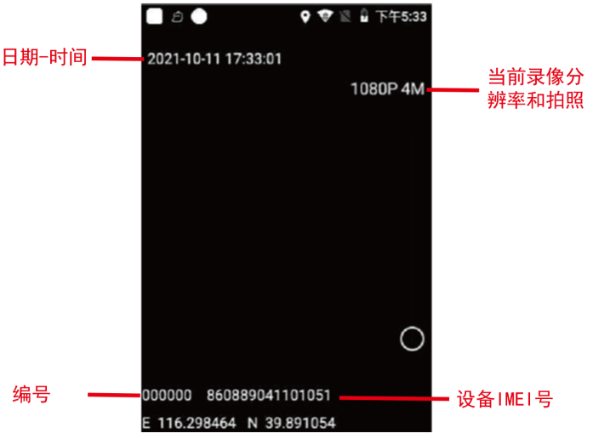

**3 information；**

ClickEnter the message notification screen, where you can view messages sent by the platform to the recorder.

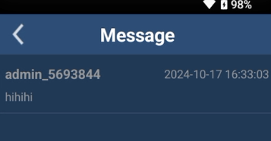

**4 File playback**

ClickEnter the playback menu, select the playback video, photos, and audio files, open the corresponding directory folder;

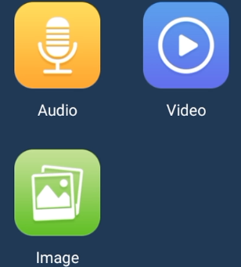

**The recording was played back**

The recording is viewed in the directory of multiple time period folders. Open a folder and click on the playback of the recording. The recording file format is.wav

**playback**

The video review directory is divided into multiple time period folders. Open a folder, which is divided into multiple files shot during this period. Play the video, the video format is MP4;

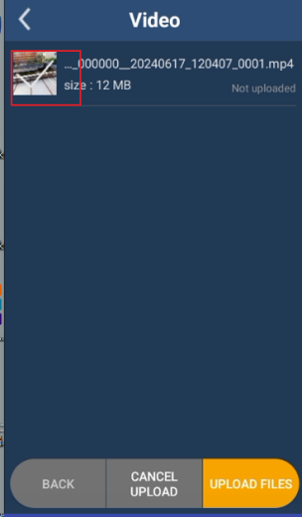

**Video replay**

In the photo review directory, there are folders divided into multiple time periods. Open a folder, which is divided into multiple files taken at this time. View photos in.jpg format

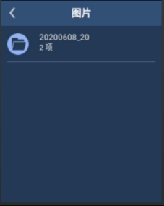

Long press the corresponding file to select whether to upload。

**5 application management**

ClickEnter the application management interface

View current organization members through the address book。

Take photos and record short videos to upload

**6 setting**

ClickEnter the Settings interface, and enter the network Settings, audio and video Settings, platform Settings, system Settings

**6．1 network settings**

ClickEnter the network Settings interface to set the server IP address and port; WIFI network connection, hotspot, Bluetooth, APN access point。

**Server Settings**：Set the platform server address and port

**WLAN set up：**WIFI

**Network sharing and portable hot spots：**Hot spots shared。

**Bluetooth：**Connect to Bluetooth Settings

**APN set up：**Access points are added manually。

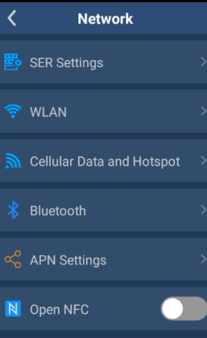

**6．2 Audio and video Settings**

ClickEnter the audio and video Settings interface to set the encoding mode, recording resolution, camera resolution, recording bit rate, file length, and recording mode。

ClickYou can change the way the recorded video is encoded. Support for H264 and H265.

Click to change the recording format of the video

Click to change the quality of the image

Click can change the video code rate

Click to change the video segmentation

Click to change the video recording mode

Click to change the way the infrared is turned on

Click to open whether to pre-record

Click to open whether the extension record

Click  to open the silent video

Click on it to open the covert recording

Click on it to open the loop video recording

Click on it to open the sound prompt

Click on it to open the vibration prompt

Click to open the video fast-forward multiple

Click to turn on the noise suppression

Click to turn on the echo suppression

Click on it to enable the microphone gain

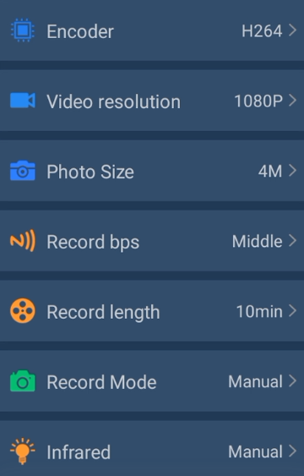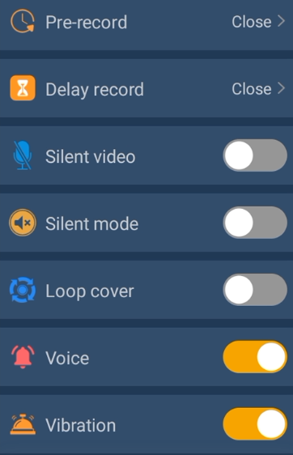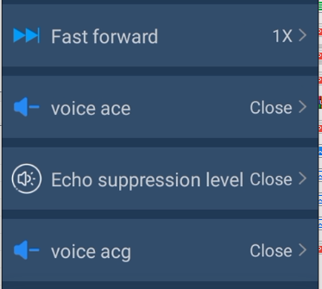

**6．3 Platform setup**

ClickEnter the platform setting interface to set the network resolution, network bit rate, GPS reporting time, answering switch, version update and account switching.

Click  can change the resolution of the network transmission;

Click to change the network transmission frame rate:

Click can change the network code transmission rate;

Click to change the positioning mode;

Click to change the location frequency:

Click to enter the GB account configuration;

Click on it to open the one-way call of the GB account;

Click to change the GB account positioning mode;

Click to open the Onvif;

Click to change the number of online device notifications;

Click on it to change the upload method of the file after shooting;

Click to open the device to automatically answer the call of the dispatching station;

Clickto view the traffic usage;

Click on it to view the software version;

Click to switch the device login account, in the switch mode can open the device account network after automatic login

Click more to modify the default server address. After changing the server address, then enter the account password to log in.

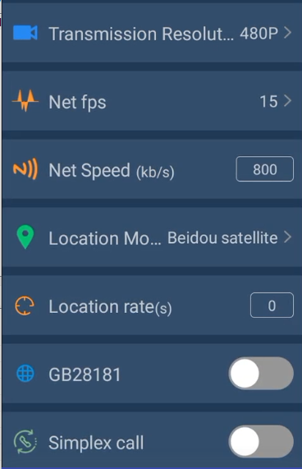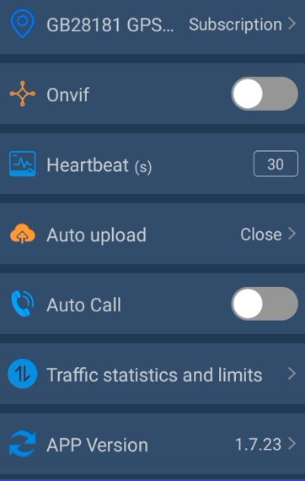

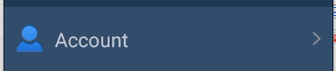

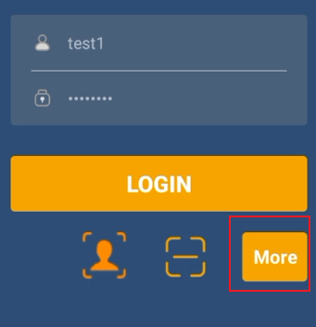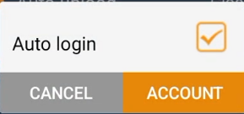

**6．4 System Settings**

ClickEnter the system Settings interface

Represents the user number issued by the web terminal to the device;

Click to change the volume of the device;

Click to change the brightness of the device;

Click to change the display language of the device;

Click to open the U-disk mode to use the device as a disk;

Click to set the password for the file playback;

Click to open the security isolation, open the security isolation usb after the computer can not click Settings and application management;

Click to view the network information and system information of the device;

Click to enter the system management;

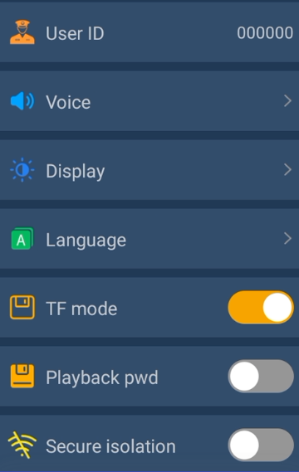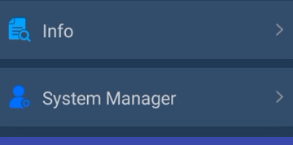

**We are committed to continuously optimizing the product. The product supports online upgrade. After the upgrade, some details may not be consistent with the actual product. Please refer to the actual product for details. Thank you!**

# Frequently asked questions

1. After connecting to the computer, I can only charge, but I cannot read the recorder. What should I do?

* Turn off third-party mobile assistants on your computer。
* Plug and unplug the data cable or replace the computer USB port。

2．What if you can't connect to the Internet？

* Close and reopen WIFI。
* Insert the SIM card again。
* If the 4G card is overdue, you need to renew it in time。

3．What if the location fails？

* The device is located outdoors, and the indoor or the scene around the device with severe shielding cannot be located normally。
* Check that the device network connection is normal。

4．What if the boot fails？

* The recorder is out of power. Please connect the power adapter to charge for at least 30 minutes in the off state。

5．Can't talk on the phone

* Please confirm whether to contact the dealer for server docking
* Make sure the network is working properly